ECE 465 Lab 8
Finite State Machines
Summary
In this lab, we will review the definition and functions of Finite State Machines, and introduce how they’re written in the Verilog language. You will also construct a simple FSM in circuit verse using the elements of what makes an FSM. Furthermore, you will construct another simple FSM in the Verilog language.
Part 1.
- A finite state machine can be applied to behaviors and sequences. How would you design a finite state machine with the following states. Idle, Walking, jog, run, and sprint. The constraints being, you cannot skip a state of speed ie idle to running. The machine must also be Moore.

- After construction of the state diagram, construct a state transition table that corresponds to part a.

Part 2.
- In circuit verse, you will create either a Mealy or Morre machine with two inputs, an arbitrary combinational circuit, a memory element, and an output, be sure to explain which one you’ve created.

Part 3.
- In Verilog, you can construct an fsm. To do so, you must create the sequential logic, and then the combinational logic of the state machine. Rather than construct a state machine from scratch, this lab will have you fill in the blanks.
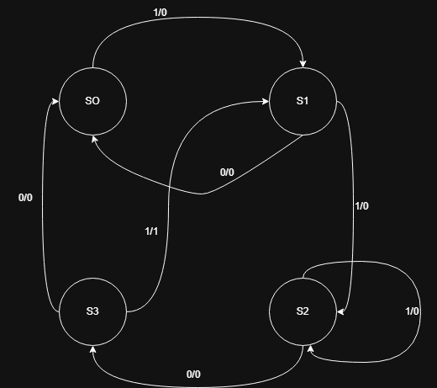

Look at the following Verilog code. You’ll notice there are some blanks in the code. The final part of this lab is to fill out the blanks.
- The following block of code creates the parameters for the state machine using binary encoding, where each state represents a binary number. Fill out the blanks in the code.
parameter S0 = 2'b00;
parameter S1 = _____;
parameter S2 = 2'b10;
parameter S3= _____;

- The next block of code represents the sequential block of the machine. Fill in the blanks.
always @(posedge clk or negedge rst_n) begin
if (!rst_n) begin
current_state <= ___;
end else begin
current_state <= ____;
end
end

- Finally, finish the switch statement that pertains to the next state and the output logic of the state transitions according to the state diagram

always @(*) begin
// Defaults: remain in current state, output low
next_state = current_state;
out = 1'b0;

case (current_state)
S0: begin
if (in == 1'b1) begin
next_state = __;
end else begin
next_state = ____;
end
end

S1: begin
if (in == ___) begin
next_state = __;
end else begin
next_state = __;
end
end

S2: begin
if (in == 1'b0) begin
next_state = __;
end else begin
next_state = __;
end
end

S3: begin
if (in == 1'b1) begin
next_state = __;
out = 1'b1;
end else begin
next_state = S0; // Sequence broken
end
end

default: begin
next_state = S0;
out = __;
end
endcase
end

endmodule

